Matrix A, B: A*B 不一定等于 B*A, matrix乘法direction matters

Identity Matrix: I*A = A: 1 in diagonal position.

Why it works? Row information from indentity matrix 的row and column information from A的column, 比如[1,0] 乘以 or , 0 cancel out every elements 除了first term (a,b) in the column vector, 第二行[0,1] cancel out every elemts 除了second term(c, d)

**Inverse 2*2:**

Calculate the inverse:

Determinant:

Indentiy matrix: I*A = A, A*I = A, 两个都满足的只有当A是square matrix的时候

**Inverse 3*3: Gauss Jordan elimination (augment the matrix, operation: elementary row operation)**

Perform some operation 在left side and same operation on right side, 当have indentity matrix在left-hand side(变成indentiy matrix的形式 叫做reduced row echelon form ), right-hand side就是原来的invers

Row3 = row3 – row1

Swap row3 and row2

Row3 = row3 – 2*row2

Row1 = row1 – row3

Hint why this work: 当对左面matrix进行操作可以想成乘以多个matrices，so we multiply matrix 得到indentity matrix, 乘以的多个matrices就是, 而我们知道identity matrix乘以任何matrix就是matrix itself

Solve system of equations (2*2):

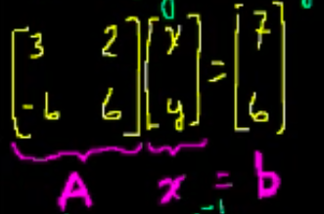

Ax = b 🡪 🡪 🡪

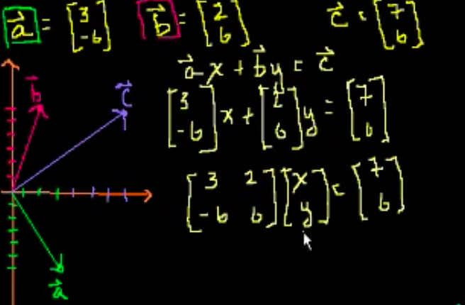Matrices to solve vector combination: 可以想成matrix multiplication problem把两个vector合成一个vector

比如vector a = , b = , 得到 c =

A = * =

, , 需要1个a,两个b

Singular matrices: 没有inverse的matrix

Prove: 比如

得到 => 如果 两条线平行, 不会相交没有解

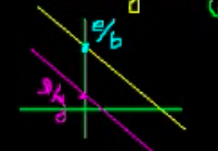

如果从vector角度考虑，如下图 是重合的 if , 无法由, , 构成

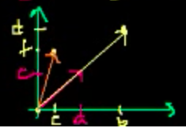

Solve system of equations (3*3):

通过row operation 变成

Vectors and Spans:

Set Colinear vectors: {c 比如vector在一条线上(slope),

Linear Combination: ; We can fill Any point in with combination of vector a and b: we can write , we can represent any vector in with some linear combination of a and b where a and b cannot be collinear (a,b 不能共线, 换种思维考虑: 如果共线了,组成的matrix没有inverse A*c = b, A没有inverse). = (c)

比如 unit vector , 可以构建任何vector in by using these unit vectors

: The space of all of the combination of vectors

**Linearly Dependent set**: some vector in the set can be represented by some combinations of other vectors in the set, 比如是linearly dependent, 再比如 是linearly dependent,因为其中一个可以由另外两个构成构成

:

**V is Subspace of**  ( me vector from ) 必须满足：

1. V contains 0 vector
2. If in V then any scaler c: also in V (closure under scaler multiplication)
3. If in V and in V, + also in V (closure under addition)

同样如果满足这三个条件的也是subspace

e.g. v = {0} = : v 只有vector 0, v is subspace of

1. 满足条件1, vector 0 在v中

2. 满足条件2: c

3. 满足条件3:

e.g. S =: v is not subspace of

1. 满足条件1, vector 0 在v中

2. 不满足条件2: -1, -1*a 为负数

3. 满足条件3: a+c是正数 given a>=0 and c>=0

e.g V = . is valid subspace of

1. 满足条件1:

2. 满足条件2: ; then ; can be arbitrary constant, 因为span是all linear combination 所以新的也在span当中

3. 满足条件3： ; , then , it also in span

e.g V = . is valid subspace of

1. 满足条件1:

2. 满足条件2: 就是span itself (combination of vector)

3. 满足条件3： ; 在span当中

**Span() of any vector is valid subspace,**

**Basis S= {}: 1. Span(all those linearly independent 2. = 0 when**

Basis(minimum set of vectors that spans the subspace): 如果用any vector in S 可以construct any vector in subspace V

e.g. T = {, }, the span of T is still going to be subspace V but T is linearly dependent -> T is not basis for V ()

Basis: 比如, 需要两个non-redundant vector

Standard Basis for

Advantage of Basis: represent any vector in subspace by some unique combination of vectors in basis 比如Basis {} 是unique的

Vectors Dot Product

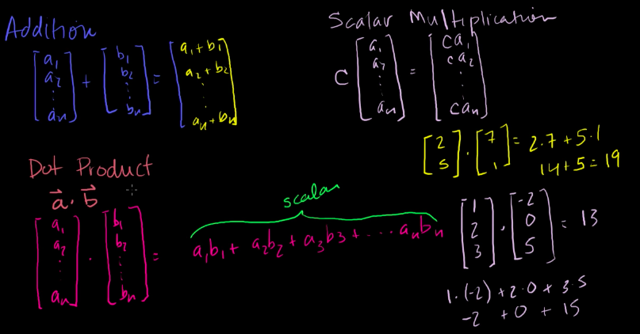

Length :

Communicative:

Distributive: ( =

Associative:

**Cauchy Schwarz Inequality**: If , only if two vector colinear, one vector 是另一个vector乘以的倍数 ()

Prove: suppose is non-zero vector

此时设

Take square root

When

**Triangle Inequality**:

根据cauchy Schwarz inequality: dot product 可以是负数

当

doesn’t need to only 2-dimensional, 可以是n dimension

**Triangle Angle between vectors**:

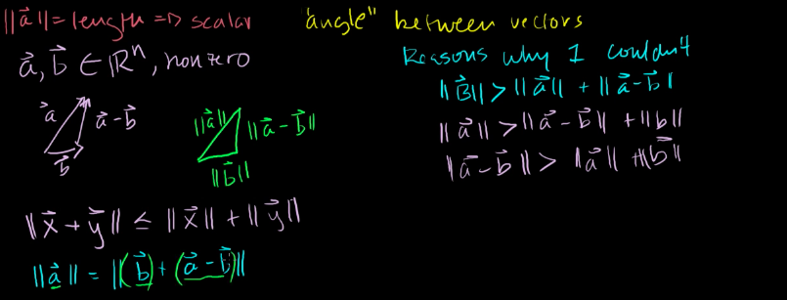

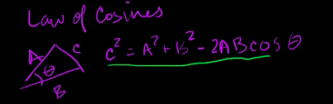Law of Cosine

Left-hand side

Left-hand side = right-hand side

If

Perpendicular

但是如果dot product = 0 不意味着垂直, 比如

但是当a, b都是nonzero vector, dot product 意味着垂直(perpendicular)

=> orthogonal, zero vector is orthogonal to everything; perpendicular is orthogonal, 但是othogonal 不是perpendicular

Dot Product:

Cross Product: only defined in ， 得到vector

Cross product 乘积是 orthogonal to and

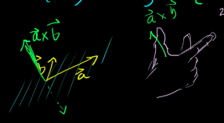

判断cross product的方向可以用right hand rule, 食指指向a的方向, 中指指向b, 大拇哥的方向是a 和b的cross product

Prove Orthogonal for and : (Same for )

Prove:

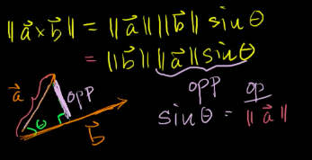

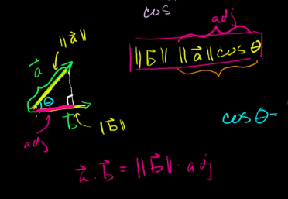

构成直角三角形的a的projection是adj

构成直角三角形的高

Dot product tells: product of lengths of vectors move together at same direction with b. When , perpendicular, onto is zero

Cross product tells: product of lengths of vectors move perpendicular direction with b. When , perpendicular, 获得最大值, 当a和b colinear, no perpendicular vector

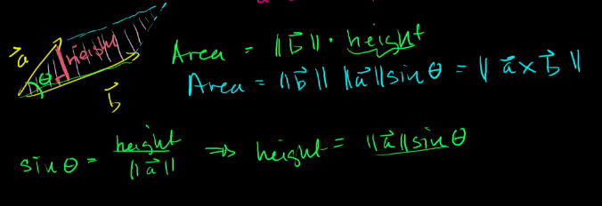

Cross product还可以算平行四边形的面积

Rowe chelon Form:

Pivot entry: 那个column只能它不是0，且那行前面没有数

Free-variable: row中在pivot后面的variable

Matrix Vector Product

1. As row vector and x dot product

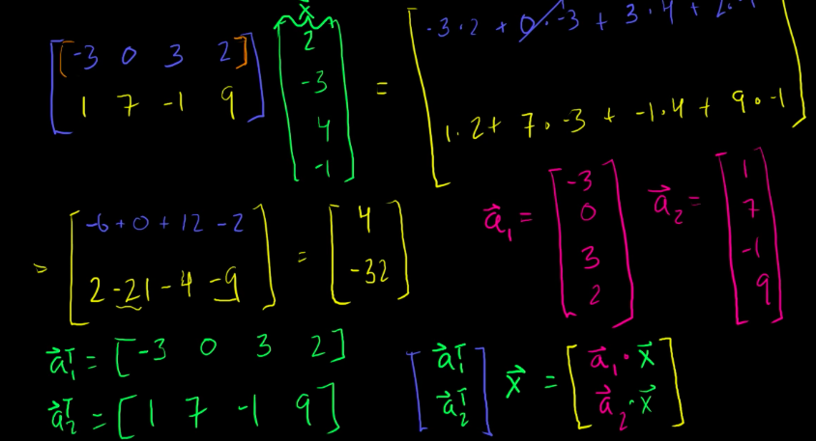

1. As column vector and x linear combination

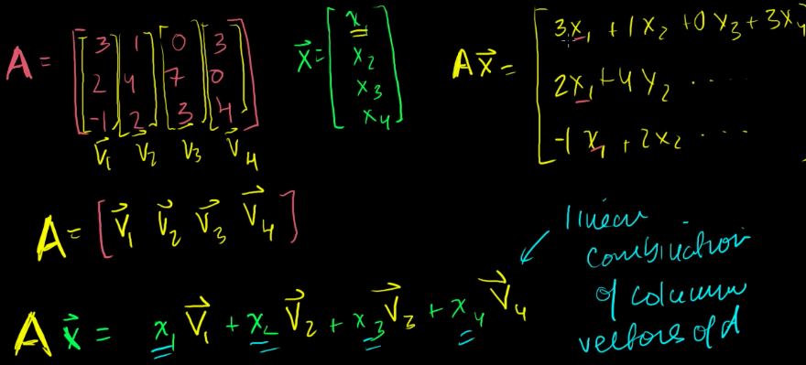

Null Space

满足1. in this subspace; 2. If ; 3. ; N is valid subspace

e.g 求

得到augmented matrix in row echelon form:

Original problem can be transformed to , (ref(A): null space of reduced row echelon form of matrix A)

**Relationship to linear Independent**

Matrix A (M N); Null space , ; 把A用column vector来表示

如果 都是linear independent, 唯一的解是 都是0

, which means no free variable

if only if column vectors of A linear independent (only do if A is N N matrix)

Column Space

满足1. in this subspace (用每个vector乘以0); 2. If ; 3. ; C(A) is valid subspace

e.g.

Row echelon form:

Is linear independent? 因为null space contain .,所以是linear depenent set

因为是linear dependent （后两个是redundant的）

， is a basis for C(A)，跟row-reduced echelon form pivot所在的column到原来的matrix中选basis

求column space的function:

我们知道cross product 垂直于, normal vector

另一种方法: what kind of B will give valid solution

化成row echelon form:

为了让system 有解 2x – y – z + 3x = 5x – y -z = 0

Dimension

Dim(V) : the number (cardinality) of a basis of V (比如 is a basis of V, Dim(V) = n )

All basis of the same subspace must have the same number of elements

Dimension of Null space: Dim(N(B)) is the **Nullity** = number of **free variables** (non-pivot) in reduced echelon form in Matrix A

e.g.

两个free variable , Dim(N(B)) = nullity = 2

Dimension of Column space: Dim(C(A)) is the **Rank** = number of **pivot variables** in reduced echelon form in Matrix A (rank of A number of linear independent column vector you have)

e.g.

To reduced row echelon form:

第1，2，4列linearly independent, column space的basis

Dim(C(A)) = 3

Linear Transformation

When function map to R (一维的) called scaler value / Real valued function

When function map to (多维的) called vector value

Transformation: function operating on vectors (linear algebra)

Linear Transformation:

如果看T是不是linear transformation 需要证明是不是符合上面的两个条件

Matrix vector products is linear transformation

Prove it is linear transformation:

Any linear matrix transformation can be viewed as matrix product

Standard basis for

Image: transformation from one set into another set

is valid subspace:

Prove: 1. 因为是linear transformation in V, 所以

2. 因为 in V, also in V

Image of T:

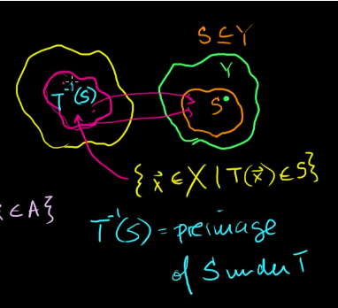

Preimage： given co-domain, what subset of domain map into co-domain, (不是每个S都需要 map 到)

**Kernel** of T: A vector v is in the kernel of a linear transformation if and only if T(v) = 0. It is the same things as null space

Sums and scalar multiples of linear transformation

Linear Transformation example:

让所有x变成负-x, 所有y乘以2

A是**diagonal matrix**: 只有对角线有值，剩下都是0;

**Unit vector**: vector has length of 1

e.g.

Projection

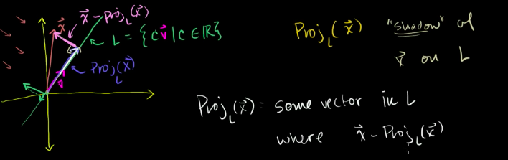

把 到L做垂线, 在L的射影是projection，垂线是 ，因为垂直dot product = 0, (

: some vector in L where is orthogonal to L

If is unit vector,

**Prove: projection is linear transformation** (is unit vector)

So

Composition

Composition: transformation of transformation

Composition is linear transformation (given S, T is linear transformation)

Prove:

因为composition is linear transformation, 可以把 写成

Associative

e.g.

Matrix product properties

Prove Distributive:

Inverse

f (function X -> Y) is **Invertible** if and only if there exist a function ( Y->X) such that

Every function if has inverse, its inverse must be unique

Invertibility implies a unique solution to f(x) = y

Prove: If f is invertible, for every , there is unique solution such that f(x) = y

For every f(x) = y has a unique solution, then f is invertibility

**Inverse is linear transformation**

Prove:

Onto & One-to-One

**Onto (surjective)**: every elements in co-domain , there exist at least one such that f(x) = y.

Every y in co-domain at least 一个x map to

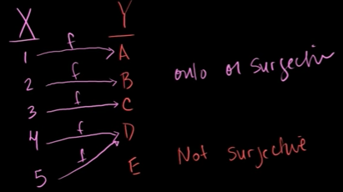

F onto then image(f) = Y

左侧是Not onto example

**One-to-one (injective)**: for every value that map to there at most at most one x map to it.

每个一个y只有一个x map, 每个x map to unqiue y: f(x) = y

上面不是onto 的例子, 也不符合one-to-one, 假如5不指向D, 5改指向E, 表示onto 和 one-to-one

**is invertible if and only if f is onto and one-to-one**

Invertible means For every f(x) = y has a unique solution, that means one-to-one, 如果有 但是没有相应的x对应，就不是invertible了, 所以invertible means onto

**T is onto iff C(A) = , its reduced echelon form has a pivot entry in every row (m pivot entry rank = M) : T is onto if and only if Rank(A) = m**

**Rank(A) = dim(C(A)) = # of basis vectors for C(A)**

Onto => for any , at east one solution where

For T to be onto which is column space, column space is

e.g

row reduced echelon form: , rank = 2, S is not onto, S is not invertible

e.g.

ow reduced echelon form

only member that has solution are the ones

solution set = , when , is the null space of T

从上面可以看出: Assuming has a solution, the solution set = , some particular vector union null space; if one-to-one, at most 1 solution => N(A) has just zero vector(trival)

Any solution to the inhomogeneous system ( system will take the form (particular solution + homogeneous solution)

Prove:

Prove any solution to take the form :

**如果是one-to-one: 只能是one-solution so has to be null space has to be so are linearly independent; C(A) = , {are basis for column space, dim (column space) = n; rank (A) = N**

Invertible: 1. onto: rank(A) = m; 2. One-to-one： rank(A) = n; in order to let transformation to be invertible, rank(A) = m = n: **matrix has to be square matrix （n by n matrix）, 变成reduced echelon form 每一行每一列又有pivot entry (n by n indentity matrix)（linearly independent pivot colum**

对matrix 进行row operation 等于进行linear transformation, **linear transformation的矩阵是等同于identity matrix进行一样的row operation**

比如

Determinant

**3*3 determinant:**

e.g.

Quick way: Rule of Sarrus

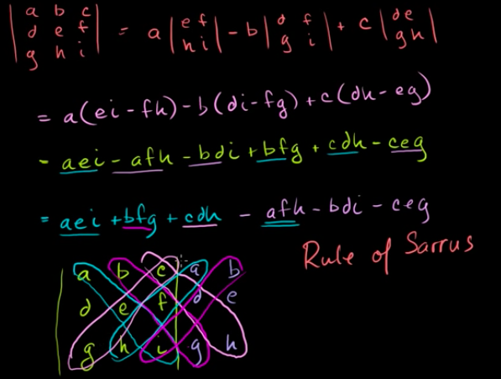

**n*n determinant:**

A = , Define matrix by ignore i-th row and j-th column

**Row 乘以scaler的determinant:**

如果row2 乘以k

如果row1也乘以k

如果是3*3 matrix row乘以k

如果是n*n matrix row乘以k

如果matrix 每行都乘以k

**When row is added的determinant:**

2*2 matrix:

3*3 matrix:

n*n matrix

Determinant operations are not linear on matrix addition